1 inch is about 2.5cm
1 foot is about 30 cm

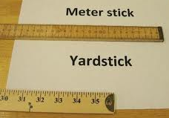
1 meter is a little longer than 1 yard 1 meter stick is about 40 inches

1 mile is slightly longer than 1.5 kilometers
1 kilometer is slightly farther than ½ mile
1 kilometer
1.5 kilomters
1 Mile

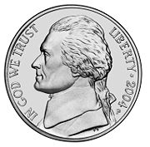
1 ounce is about 28 grams
1 nickel is about 5 grams
1 kilogram is a little more than 2 pounds
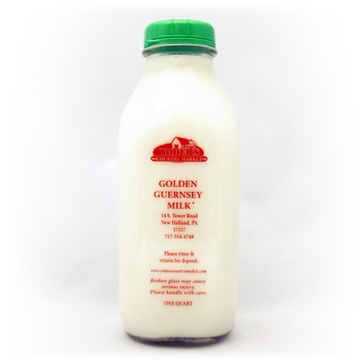
1 quart is a little less than 1 liter

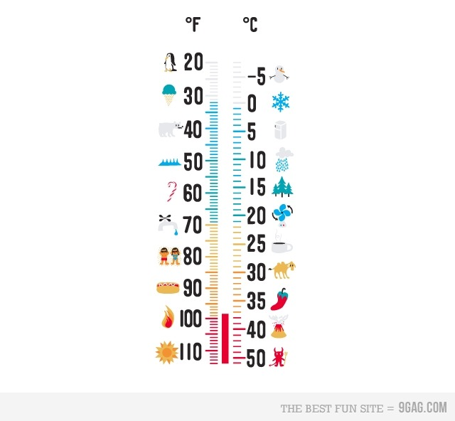
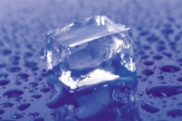
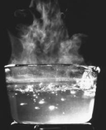
Water Freezes at 0°C and 32° F
Water Boils at 100°C and 212°F
Normal Body Temperature is 37°C and 98°F
Room Temperature is 20°C and 70°F

